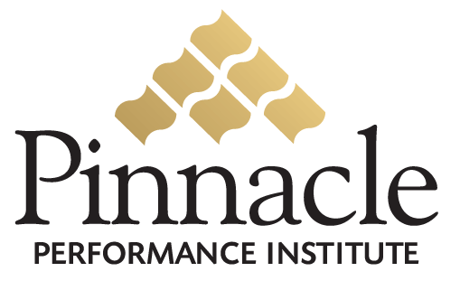

Performance Enhancement

Solution

Nexx Success Institute

Close the Gap between Vision & Execution
Expose Reality… and Act Upon It

Nexx
3291North Buffalo Drive
Las Vegas, NV 89129

Attn: Dean Tognoni
(702) 839-7000

Table of Contents
Executive Summary 2
Execution Strategy 3
Overview 3
Opportunity 3
Solution 4
Return On Investment 6
Implementation Plan 7
Pinnacle Performance Institute 8
Agreement 9

Executive Summary
Nexx, a network marketing company since 2002, distributes premier products and services from world-class providers to both the residential and small business markets. Nexx has approximately 5,000 independent distributors spanning all ages and all skill levels. Distributors represent a diversified group of men and women who are working together to exchange ideas, advance their skills, increase their knowledge, and realize their dreams.
Nexx recognizes the significant need to insure that distributors are qualified to represent the company and that they are equipped to excel at their responsibilities. Nexx also recognizes the need to train and certify their independent distributors on regulatory requirements to protect the company from legal liabilities due to unauthorized product claims, earning statements and business practices.
Pinnacle will develop a custom Nexx branded Performance Enhancement Solution to enable Nexx to train and certify their distributors on the necessary business skills for success, regulatory requirements, and qualified distributor compliance.
Nexx distributors will receive a free Development Membership with access to general and company-specific self-help assessments, certifications, electronic suggestion boxes, dynamic company surveys, goal management program, and the ability to be mentored by an experienced distributor. Nexx will be billed $0.25 per month for each Development Membership to cover Pinnacle’s expense of providing quality customer service.
Nexx distributors may optionally purchase a Performance Membership, which provides unlimited access to all interactive multimedia-training courses on company specific topics and hundreds of additional professional and personal development courses. They will also be able to access online conference rooms, online discussion boards, the support search engine on company documents and questions & answers, and the ability to mentor others for a small monthly flat-fee of only $34.95. Distributors that refer five other distributors to the Performance Memberships will receive their membership completely free.
Nexx will receive $8.95 monthly for each paid Performance Membership, $107,400 annually for each 1000 paying distributors. A conservative projected earnings increase of $500 per month for a Nexx distributor will yield an estimated $6,000 value on a $419 investment or 1431% ROI.
The regular $5000 deployment fee will be waived for an executed Pinnacle Customer Agreement on or before November 1, 2005. Nexx is required to submit a $1000 deposit with the signed agreement, to be applied to future Development Membership $0.25 fees.
A Pinnacle Account Executive will train and support the Nexx Solution Team to successfully implement the Nexx Performance Enhancement Solution estimated to be ready for use by the distributors in 30 – 45 days. The Pinnacle customer service department will also provide additional assistance for the Nexx program manager, trainers and members.

Execution Strategy

Pinnacle is dedicated to the successful integration of the Pinnacle Performance Solution within Nexx. The performance and certification benefits can contribute significantly to Nexx’ growth and profitability objectives and regulatory compliance requirements. For Nexx to fully realize the wide-ranging benefits of its Pinnacle Performance Solution, the following principles must be embraced.

Performance Solution
Your solution can significantly improve the overall performance of the entire organization including the company management, employees and independent distributors. You can effectively measure the strengths and weaknesses of all distributors. The results of the metrics will drive the effective application of the necessary development to build confidence and competence. The continual process of measuring and building is enabled with effective collaboration and accountability. When used as a platform for implementing change your Performance Solution will deliver maximum value, well beyond that of just a video training library.

Performance Culture
Your performance solution is integral to the successful improvement of the entire organization. Performance must become integrated within the culture and mindset of every distributor, employee, manager and executive. In order to Close the Gap between Vision and Execution, Nexx must expose reality… and act upon it. This requires a comprehensive integration plan rather than just another peripheral program.

Performance Commitment
Regardless of how great your performance solution is, your ultimate success will be completely dependant on the level of commitment from everyone involved including the top management down to the front-line employees and distributors representing the executed vision of the company. Each user of the performance solution must have a personal commitment and buy-in, through accountability, incentive programs and/or monetary commitments. Complete user commitment will overcome the challenges leading to integration failure contributed to a lowered priority and lowered perceived value.

Overview
Nexx, a network marketing company since 2002, distributes premier products and services from world-class providers to both the residential and small business markets. Nexx has approximately 5,000 independent distributors spanning all ages and all skill levels. Distributors represent a diversified group of men and women who are working together to exchange ideas, advance their skills, increase their knowledge, and realize their dreams.

Opportunity
Nexx recognizes the significant need to insure that distributors are qualified to represent the company and that they are equipped to excel at their responsibilities. Nexx also recognizes the need to train and certify their independent distributors on regulatory requirements to protect the company from legal liabilities due to unauthorized product claims, earning statements and business practices.
Nexx Distributors can significantly increase their likelihood of success with business assistance to lift the burden of supporting and running a successful business; and a proven formula for success to create sales, develop marketing, and manage their business.

Solution
Pinnacle will develop a custom Nexx branded Performance Enhancement Solution to enable Nexx to train and certify their distributors on the necessary business skills for success, regulatory requirements, and qualified distributor compliance.
Nexx will assist its distributors in improving their business development; increase their customer referrals, distributor retention, distributor productivity and sales conversion rates. Nexx distributors will receive a free Development Membership with access to general and company-specific self-help assessments, certifications, electronic suggestion boxes, dynamic company surveys, goal management program, and the ability to be mentored by an experienced distributor. Nexx will be billed $0.25 per month for each Development Membership to cover Pinnacle’s expense of providing quality customer service.
Nexx distributors may optionally purchase a Performance Membership, which provides unlimited access to all interactive multimedia-training courses on company specific topics and hundreds of additional professional and personal development courses. They will also be able to access online conference rooms, online discussion boards, the support search engine on company documents and questions & answers, and the ability to mentor others for a small monthly flat-fee of only $34.95. Distributors that refer five other distributors to the Performance Memberships will receive their membership completely free.
Nexx distributors will be able to significantly improve their performance by constantly measuring their strengths and weaknesses, and applying the necessary development to build confidence and competence. The continual process of measuring and building is enabled with effective collaboration and accountability.

Some of the features of the Nexx Performance Enhancement Solution include:
General Performance Solution Features
- Accessible anywhere with Internet access
- Accessible anytime 24 hours a day, 7 days a week, 365 days a year.
- Secured Access with personal logon name and password for each user
- Secured back-office for program managers, group managers, trainers and members
- Streaming video training supports dial-up and broadband users
- Single flat fee includes unlimited access to everything
Performance Solution Administration and Management
- Custom graphics, pages, colors and training buddy image & biography
- Custom Groups for specific performance goals (departments, roles, projects)
- Public, Private and Semi-private Groups
- Group inclusion of specific members and required or recommended courses
- Selection of public or proprietary assessments and training courses
- Dynamic Surveys to collect performance feedback from team members and customers
- Online conference rooms and discussion boards for each Group
- Electronic suggestion boxes for each Group
- Define expectations for each Group
- Email Manager to send scheduled messages to select members
- Management reporting on member status, usage, and training accomplishments
- Management reporting on member certification and goal accomplishments.
- Managing Buddy to guide the Manager through the necessary administration.

Member Performance Solution
- Member Profile to maintain contact information and secured logon and password
- Training Buddy to assist with all aspects of the solution
- Personal status tracking of all assessments, classes, communications, etc.
- Accountability goals to establish a culture of execution
- Mentoring Program for leaders to mentor their team
- Assessments to measure personal and professional needs
- Diagnostic Assessments to address specific problems/needs
- Training Prescriptions for specific individual needs
- 1000+ public training courses on all aspects of life
- Selected company-specific training courses
- Course ratings and feedback from other members
- Multimedia lessons with downloadable attachments
- Take class notes organized by topic and printable
- Lesson quizzes with multimedia questions
- Company branded professional certificates
- Personal expectations for each accessible group
- Group online conference rooms and discussion boards
- Electronic suggestion boxes with reviewable responses
- Company surveys with anonymous feedback
- Search Engine for Company Support Documents and Questions & Answers

Trainer Performance Content
- Trainer Profile to maintain contact information, picture and biography
- Unlimited number of company trainers
- Maintain secured logon name and password
- Create courses with unlimited number of lessons
- Lesson content of text & pictures, video, audio, Flash, PowerPoint, website links, etc.
- Downloadable lesson attachments for workbooks and reference sheets
- Lesson Quizzes with unlimited multimedia questions
- Quiz questions are multiple choice, fill-in-the-blank, or true/false
- Create assessments to determine proficiency scores
- Create diagnostic assessments to solve specific problems/needs
- Define training prescriptions for specific needs.
- Unlimited multimedia assessment questions
- Assessment questions are multiple choice, fill-in-the-blank, or true/false

Return On Investment

Nexx will have an estimated internal investment of $36,000 annually for management and promotion of the solution, Projected revenue for 1000 memberships at $8.95 per month will yield an annual profit of $107,400 or 298% (3 times) Return on Investment.

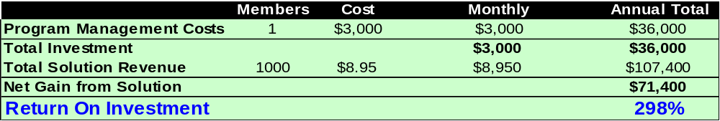

The Nexx distributor will have an estimated investment of $34.95 monthly for access to the solution. A projected earnings increase of only $500 per month will yield an estimated $6,000 value on a $419 investment or 1431% Return on Investment.

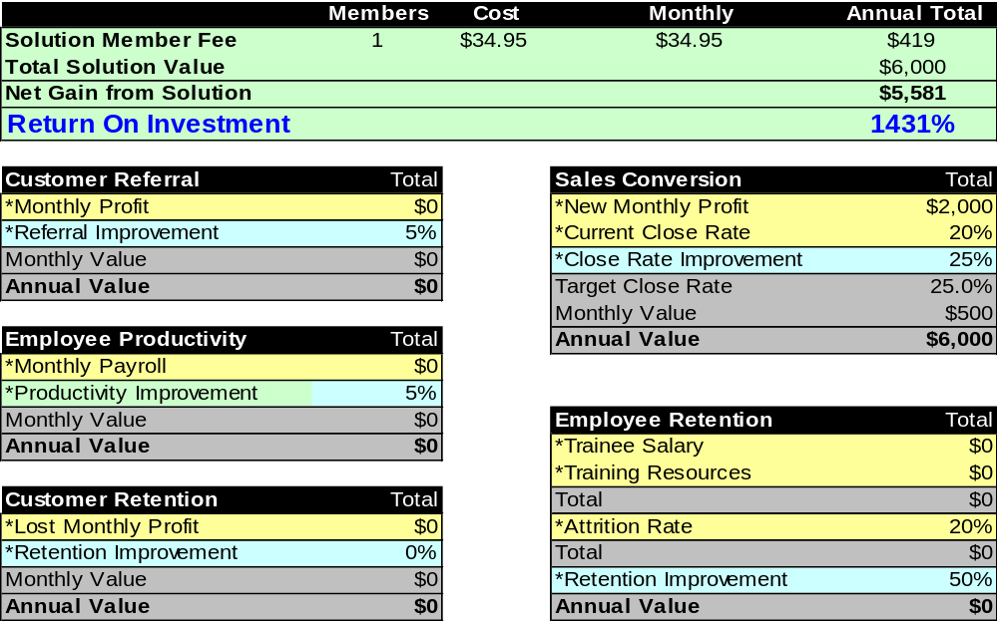
Solution Development Plan
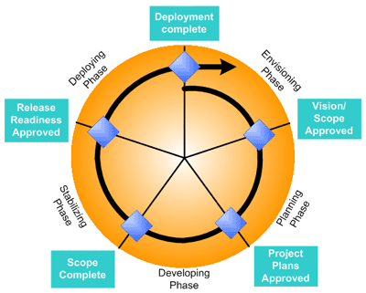
The Nexx Solution will be developed by a team of individuals representing all aspects of the project including the business requirements and customer expectations, the project schedule and status, the construction of the solution, the user experience, the quality control of the solution, and the smooth deployment of the solution. A development process will be implemented to address the project scope and vision, the agreed upon deliverables, priorities and expectations, the building of the solution, the testing phase, and the solution rollout.
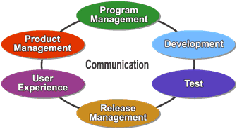

Team Role | Key Performance Goals and Responsibilities
Product Management | Customer Satisfaction  Drive solution planning, articulate customer requirements, conduct research and analysis, manage customer expectations, manage business value, and solution promotion.
Program Management | Delivery within project constraints  Manage project schedule and scope, facilitate communication and collaboration, and drive on-time delivery of the solution.
Development | Delivery to product specifications  Evaluate feasibility, Build solution content, support stabilization and deployment
Test | Release after addressing all known issues  Develop test plans, perform content testing, track and communication issue resolution
Release Management | Smooth deployment and ongoing management  Coordinate with operations, ensure infrastructure support
User Experience | Enhanced user effectiveness  Manage user requirements, drive user interface design, train users

Phase | Mission and Milestones
Envisioning | Define Project Goals and Expectation  Vision/Scope approved by Product Management. Core team organized
Planning | Define what needs to be built, timeline, and procedures  Project Plans approved by Program Management. Functional Specification, Project Plan and Project Schedule base-lined.
Developing | Build, test and refine all aspects of the solution  Scope Completed by Development and User Experience. Source documents, inventory documentation, support documentation.
Stabilizing | Test solution and prepare for final release to production  Release Readiness approved by Test and Release Management, Bug reports, user acceptance.
Deploying | Deploy Solution into live production environment  Deployment Completed by Release Management. Production plans and support.

Pinnacle Performance Institute
The Pinnacle Performance Institute shows companies how to clone their top performers to significantly increase their profits. It does this with a very affordable online Performance Enhancement Solution customized to their specific needs in order to Measure their strengths and weaknesses, Build confidence and competence, with Collaboration for team synergy, and Accountability to establish a culture of execution. The Pinnacle Performance Solution empowers companies to Close the Gap between Vision and Execution by exposing reality... and acting upon it.
Companies can leverage Pinnacle’s dedicated technical and business expertise in delivering a professional quality solution to maximize the performance of the Company, allowing the customer to continue to focus on its core competency.
Pinnacle provides advanced technology architected for large enterprises to support scalability with a multi-tier client-server architecture, flexibility for quick modification to meet changing business requirements, maintainability with industry standard technology, and dynamic multi-lingual support for international markets.
Pinnacle provides a quality solution ready to implement immediately to capitalize on the current window of opportunity. Pinnacle overcomes the challenges that all companies face in developing the necessary systems to meet their fast-paced and ever-changing business objectives. Comparable systems can take a development team 12 to 18 months at least to design, develop and deploy, assuming they have the technical and business expertise.
The Pinnacle Performance Institute, headquartered in Plano, TX, is a premier technology company with a passion for performance. Pinnacle leverages technology in assisting companies to “Close the Gap” between their vision and their execution.
The Pinnacle Performance Institute was founded and architected by Mr. Robert A. Wood, who has been a senior technologist for over 25 years with both Ross Perot and Bill Gates and founded Shabang.com during the Internet gold-rush, raising $15M and building it to a $200M corporation. He also founded the underlying technology company, WinTech, Inc. in 1995 and has served as its President & CEO from its inception.
Mr. Wood served as the Chief Technology Officer, President & CEO, and Chairman of the Board of Directors for Shabang.com, an online e-commerce solution for merchants. From 1990 to 1995, Mr. Wood served as Senior Consultant and Developer with Microsoft Corporation. While at Microsoft he was responsible for assisting both the management and technical staffs of Fortune 500 corporations in understanding, architecting and constructing distributed application architectures. Mr. Wood was president of Executive Micro-Systems from 1988 to 1990 and a systems engineer for Electronic Data Systems Corporation (EDS) from 1985 to 1988.

Pinnacle Customer Agreement

Nexx Dean Tognoni
3291 North Buffalo Drive dtognoni@nexx.net
Las Vegas, NV 89129 (702) 839-7000
www.Nexx.net
X | Bill Members Directly |  | Bill Customer For All Memberships |  |  |  | Bill Credit Card |  |  | Bill Electronic Check

I understand that Pinnacle agrees to:
- Provide the Customer with a private-labeled Pinnacle Performance Enhancement Solution to train and monitor its members, employees and/or independent agents.
- Provide the Customer with a secured Internet back-office to customize and maintain its Pinnacle Solution.
- Provide the Customer’s members with secured Internet access to the Pinnacle Solution.
- Maintain an independent Customer relationship, preventing any suggestion of Customer endorsement.
- Maintain confidentiality of all customer and member personal and financial information. Such identified confidential information will only be used to fulfill the Pinnacle Solution service.
- Recognize Customer ownership of the original content while maintaining ownership of its digital conversion.
- Reserve the right to approve or disapprove any and all training content according to the appropriateness for its members at the complete discretion of Pinnacle.
- Provide a Development Membership to each Nexx Distributor free of charge to them.
- Bill each distributor $34.95 monthly for optionally upgrading to the paid Performance Membership.
- Pay the Customer $8.95 monthly for each paid Performance Membership.

I agree to:
- Provide a Program Manager for all setup needs and ongoing system and member maintenance.
- Provide the assessments, certifications and necessary training and development courses for the members.
- Provide regular major promotions for the member usage of the solution.
- Ensure that only one individual and their immediate family members utilize each membership account.
- Pay monthly fees of $0.25 per account for Development Membership to the Pinnacle Solution.
- Maintain an independent relationship with Pinnacle and prevent any suggestion of endorsement by Pinnacle.
- Maintain full and complete ownership of the original intellectual property content granting the nonexclusive right to Pinnacle to edit and convert the original content into a digital format appropriate to Pinnacle’s needs.
- Warrant that I have complete legal rights and authority to provide the training content and am not infringing any copyright or other such laws.
- Issue written notification to Pinnacle of my termination of this agreement effective within thirty days of notice.

My signature indicates that I have read and accept all the terms and conditions regarding privileges and obligations of the Pinnacle Performance Enhancement Solution as outlined on this agreement. I understand that Pinnacle will waive the regular $5000 deployment fee for this executed agreement on or before November 1st 2005. I also understand that this signed agreement must be accompanied by a $1000 deposit to be applied toward future Development Membership $0.25 fees and that I will be billed monthly for any outstanding balances due immediately.

Signature Date

Dean Tognoni, Founder

